IMAT2207 Agile Team Development
Practical – Unit 2a

Collaboration
Getting started with GitHub

Getting Started on GitHub 1
Before you Begin 1
Collaborative Tools 1
Version Control 1
Some important terms to understand 5
Getting Started – Creating a New Repository 5
Branches 7
Creating a New Branch 7
Making Edits 8
Opening a Pull Request 10
Merging the Pull Request 11
The Story So Far 12

Getting Started on GitHub

Before you Begin
Make sure that you have watched the eLectures for this week before starting this work.
One important tool that is required in team-based development projects is some sort of version control software.
In this module, we will use GitHub which is a free on-line tool. In this first exercise we will go through an individual walk through to get you started. Once you have completed this work you will be better placed to set up the team repository for your system’s code.
Work through this guide individually.

Collaborative Tools
If you plan on working together as a software development team you will need software tools to support your work.
The simple fact of the matter is that it is unlikely that you will be a “Lone Ranger” in the Computing industry.

Version Control
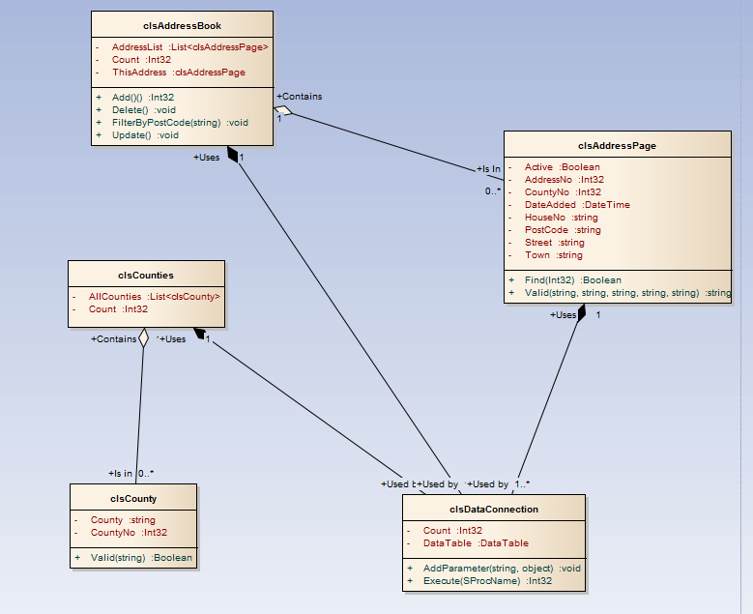
One of the problems you are going to face is how to manage version control. What I mean is this. Look at the following simple class diagram…



Let’s assume that there are two developers working on the above system, Sam and Dean.
Dean
Sam

Sam is working on the address book (clsAddressPage & clsAddressBook) while Dean is working on the classes’ clsCounties and clsCounty.
If Dean wishes to extend the rather limited functionality of clsCounties to now include Add, Delete and Update what impact will this have on Sam?
The first question is how are they sharing their code?

If the project you are working on is stored on a single computer and each developer has exclusive access to the machine one at a time, there isn’t a problem.
The workflow would be as follows…
- Dean sits at the machine…
  - Makes changes to the code for Counties
  - Saves the work to the computer
  - Goes off and does something else
- Sam takes her turn at the machine…
  - Makes changes to the address book code
  - Has access to the code Dean modified above
  - No problems with version control
Version control becomes a problem as systems start to become distributed across networks.
Dean | Sam

This situation is much more realistic. On a network Dean and Sam are going to make changes to their allocated parts of the system simultaneously.
Dean and Sam come into work at 9am with a deadline of 12pm for the system being delivered to the client.
What happens if Dean and Sam must make changes to the shared data connection to the database?

- Sam opens clsDataConnection for editing (9:00 am)
- Dean opens clsDataConnection for editing (9:05 am)
- Dean adds a new method to clsDataConnection
- Dean saves his work on the class (11:30 am)
- Sam completes her work modifying the code for clsAddressBook
- In the process Sam also saves her older version of clsDataConnection (11:32 am)
- This reverts clsDataConnection back to its original version overwriting the new code created by Dean
If the code is hosted on a central server, we could lock the original file such that Sam has exclusive access to the code. This way Dean would have to wait till she is finished. This is a problem if they are both running to a deadline and both need to make changes to the same class.
The situation is made more complicated though if, as is becoming more common today, they are both working on the code off site.
This time there are local copies of the system code across three machines. (The two off site machines and the central server)
How do we set about synchronizing the three copies of the system such that both Dean and Sam have access to the most up to date version of the code?
These are a few of the technical problems that need to be addressed when working on a system as a team.
Version control has wider implications from the point of view of the customer too.
- Dean and Sam work on the system to produce version 1.0 of the product
- Version 1 is released to customers
- More work is carried out and version 2.0 is released which is chargeable
- Some customers report that with version 1.0 there is a bug
- Customers refuse to upgrade to version 2.0 due to the cost and want a fix for version 1.0 (This will create version 1.01)
The question then arises how to manage the code not just to handle multiple versions of the code in use by developers but also multiple versions of the code over the history of the system?
It is not just an issue with the code for the system but all documentation along the way. We need mechanisms for sharing design documentation so that all changes are synchronized and logged throughout the history of the system.
One solution is to use a cloud-based repository hosting service such as GitHub for storing, tracking and collaborating on software projects.

To get started with GitHub create an account here: https://github.com/

Some important terms to understand

- Repository This is a project containing code and associated files that you want to share with your team
- Main Branch The main version of the system
- Feature Branch A version of the repository that is currently under development by a member of the team
- Commit A change made to a version of the system in a feature branch
- Pull request A request to merge the changes in a feature branch back into the main branch
- Merge The act of merging a pull request back into the main branch
- Cloning Making a local copy of a repo in the cloud

Getting Started – Creating a New Repository
(The following notes are adapted from GitHub’s Hello World example https://guides.github.com/activities/hello-world/)
To get started we will begin by creating a new repository.
In the top right-hand corner of the interface drop down the menu to create a new repository like so…
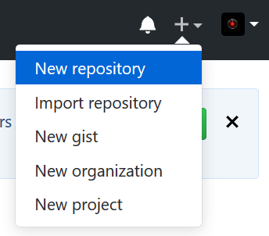

You will see the following screen…
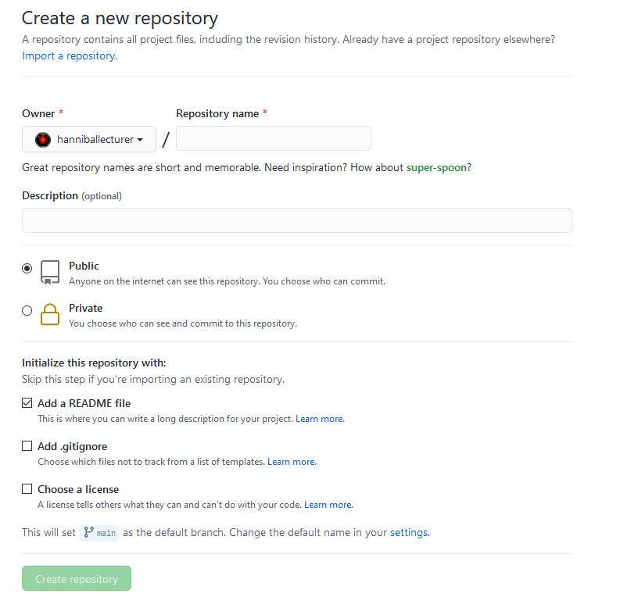
Set the name for the repository – in this case “hello-world”.
Write a short description and make sure you select “Initialize this repository with a README” (This will automatically generate a file we can play with.)
Once done, click “Create repository”
This should then display the new repo (short for repository!)
(see next page)
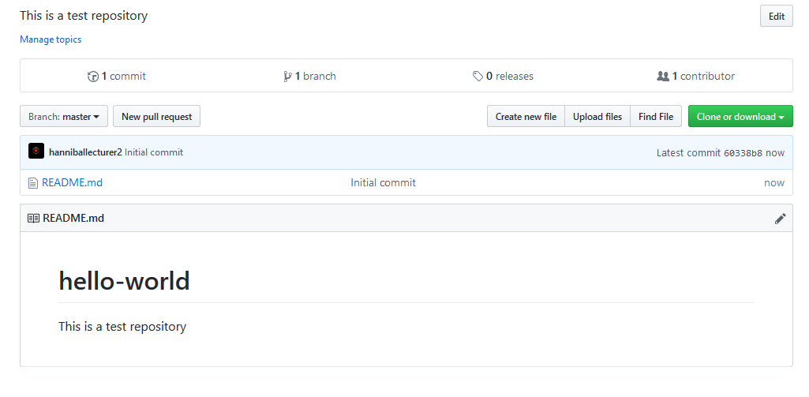Having created the repository, we need to create a new branch.

Branches
By using branches each member of your team may work on a different version of the system at the same time.
Things to remember about branches…
- Branches should have a very short life span
  - 48 hours is a long life for a branch
  - Any code developed by a team member in a branch is not available to other team members
  - Complete a suitable unit of work in a branch then merge it with the main branch
  - Only “good code” from branches is to be merged with the main branch
  - Once a branch is merged it needs to be deleted
Typically, in working on a branch you will be working on a specific “feature” of the system.
Let’s assume that a member of the team now wants to work on the hello world project. We don’t want them to change the main branch until they are sure that the changes are tested and working correctly.
From the main branch the team member needs to create a new feature branch. They will work on the code within this branch and once completed merge it back into the main branch.

Creating a New Branch
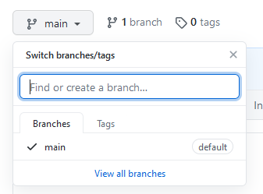
To create a new branch, select the Branch drop down menu from “Main”…

Create a name for the branch readme-edits and select create branch…
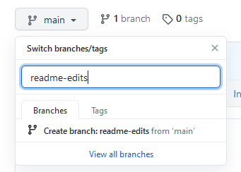
Since this branch is a copy of the main branch, they are currently identical.
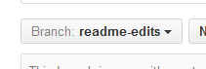
Note that the branch drop-down menu now points to the new branch not main …

You may switch between branches using this menu, but I wouldn’t advise you to have more than one personal branch open at a time.

Making Edits
Having created the new branch, we will edit it and save the changes. This is called a “commit”.
Each commit created during the development of the system will provide a history of changes made.
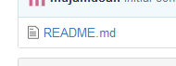
Click the file readme.md

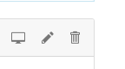
Now click the pencil icon in the top right…

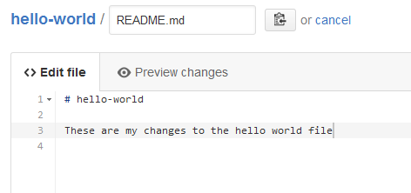
Edit the hello world file in some way…

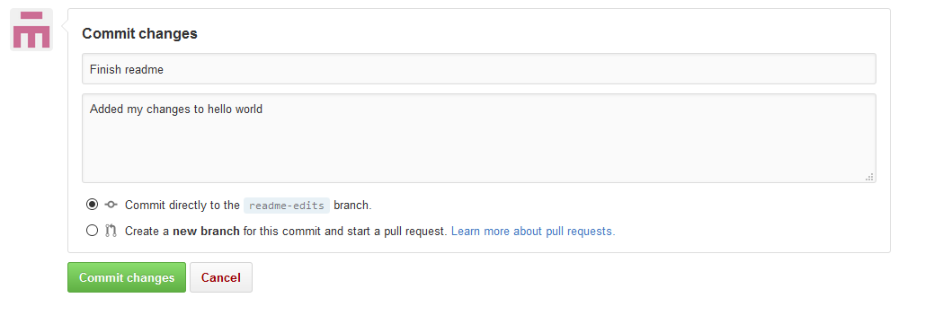
Also scroll down and add a commit message that describes your changes…And commit the changes.

This will update your copy of the hello world file; the copy in the main branch is still the original version.
Now that you have made a change to the branch look at the file in the main branch. You should find that it still contains the original version.
If another developer wants to edit the file, they would create their own branch based on the main and work on that file, not the one you are currently editing in your branch.

Opening a Pull Request
Having edited the content of the branch it needs to be merged (pulled) back into the main branch.
To do this, click the pull request tab…
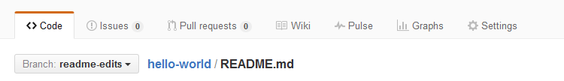
Select new pull request…

Select the base branch as main and the compare branch as readme-edits…
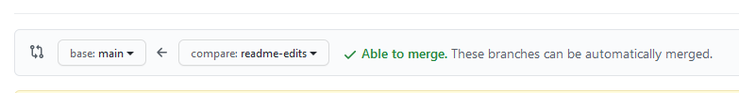

Git will now look at the two branches identifying what has changed between the two…
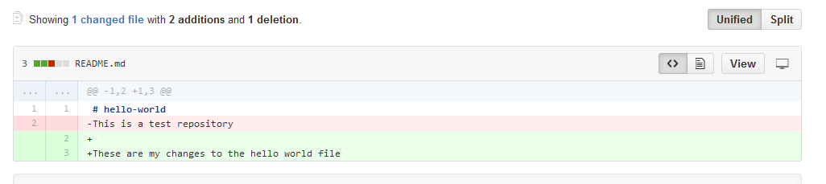

If it all looks fine, select ‘Create pull request'…

Enter the details for what has changed in the pull request…
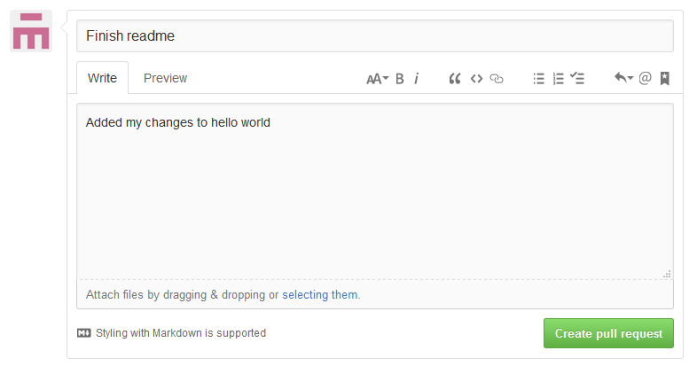
Then create the pull request.

Merging the Pull Request
Having created the pull request, it needs to be merged back into the main branch.
To merge the pull request, select merge pull request and confirm merge…
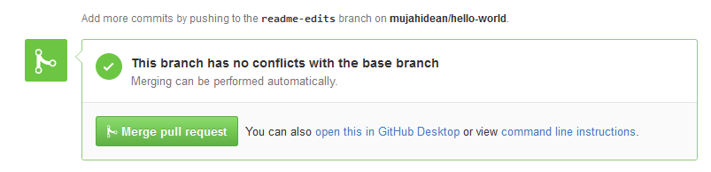
You should then get a confirmation message like so…
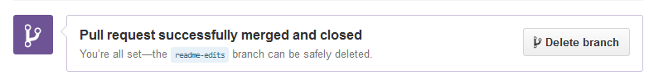
Having merged the changes in the branch with the main branch you need to delete the unwanted feature branch.

Having merged your branch to the main your changes are now available to other developers as they make changes to the file.

The Story So Far
In working through the above tasks, you have progressed through the typical workflow of a project in GitHub.
You have:
- Created a repo
- Created a branch
- Modified files in a branch
- Opened and merged a pull request
- Deleted the unwanted branch

This is a basic introduction to your typical Git Hub day.
It will likely seem confusing at first but once set up in Visual Studio and you have carried out the procedure multiple times it will become second nature.

